REGISTRATION FORM for ATTENDEES
The lost-and-found: revising art stories in search of potential changes
International Symposium – Lisbon, December 6-7, 2023

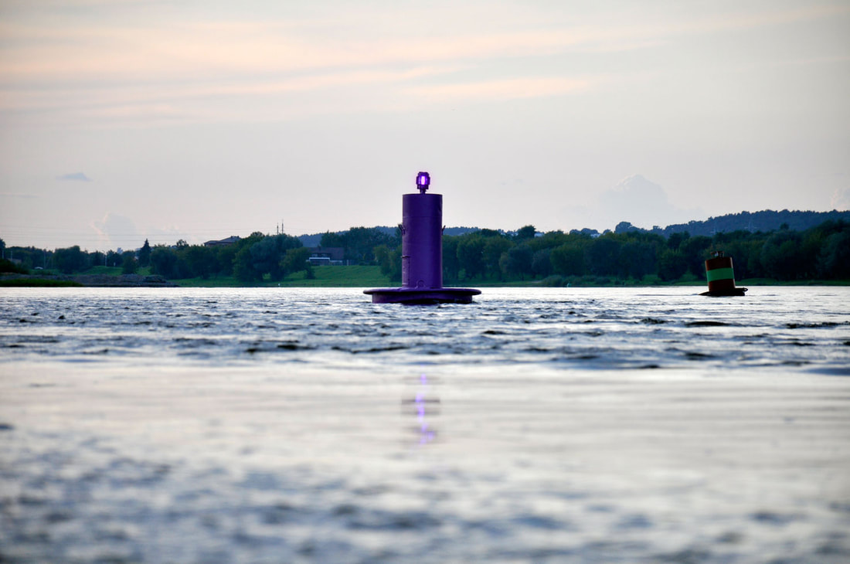
Karolina Freino, Confluence. The Monument to Emma Goldman, 2017.

- PERSONAL DATA
NAME:
AFFILIATION:
ADDRESS:
COUNTRY:
EMAIL:

- REGISTRATION FEE (3€)
The fees include all coffee breaks during the two days of the symposium.

- LUNCH and DINNER (optional)
Lunch on 6 and 7 December and dinner on 6 December are optional. The cost is payable separately.

Lunch day 1 | 25 EUR ☐ yes ☐ no
Lunch day 2 | 20 EUR ☐ yes ☐ no
Dinner day 1 | 30 EUR ☐ yes ☐ no

- RECEIPT
NAME (individual participant or institution):
ADDRESS:
TAX/VAT NUMBER:
The receipt will be issued and sent by email in the subsequent month from the date of confirmation of registration.

Please note that once the receipt is issued it will not be possible to change these details.

- PAYMENT
Registration fees must be paid by bank transfer. All additional transfer fees must be paid by the participants. No refund will be possible.

PAYMENT BY BANK TRANSFER:
Registration fees must be paid to the following account:

Bank: Banco Santander Totta S.A.
Beneficiary/Account holder: FCSH – Univ. Nova de Lisboa
Address: Avenida de Berna, 26-C, 1069-061 Lisboa, Portugal
IBAN: PT50 0018 000321419114020 13
BIC/SWIFT: TOTAPTPL

Payment description (mandatory): Lost and Found Symposium – IHA-NOVA FCSH

- TERMS AND CONDITIONS
To complete your registration, you must send this form to the Symposium e-mail address: lostandfoundlisbon@gmail.com, together with the bank transfer receipt.
Your registration will be confirmed by e-mail after we have received these documents and payment. Please note that, in case of withdrawal or cancellation of your participation, it will not be possible to refund any registration fee previously paid.

By filling in and returning this form, you agree to have read and accepted these terms and conditions.

All data provided will be treated as confidential. Under no circumstances will the data collected be used for any purpose other than that the context of this event.

Touchpoints:
Beatriz Laschi
Basia Sliwinska

Organization:
Art History Institute - Universidade NOVA de Lisboa (Portugal)
University of Wrocław (Poland)
Polish Institute of World Art Studies
Art Academy of Latvia in Riga (Latvia)

Website: thelostandfoundlisbon.weebly.com
